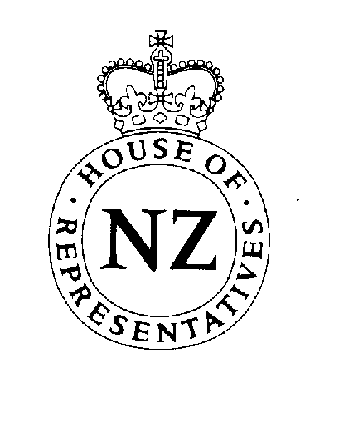
A Business Update from United Future New Zealand

Current legislation – where we stand

OSH Amendment Bill – I have already described this Bill as being on “the lunatic fringe of lawmaking” with its excessively heavy fines on employers if they fail to recognise undefined ‘stress’ levels in their employees. The Bill has been reported back from select committee with some changes, but we remain unconvinced this is a Bill that will promote the good health of business in New Zealand. This could turn out to be the Slackers’ Charter whereby the idle and the malcontent try to get the State and employers to fund a work-free lifestyle.

Climate Change Response Bill – this Bill, which has been reported back from the select committee, does not ratify the Kyoto protocol governing greenhouse gas emissions, but establishes the mechanisms that will allow the protocol to be enforced once ratification has occurred. United Future has concerns that ratification too early will place New Zealand business at a serious disadvantage to overseas competitors who either will not, or are not obliged, to go along with the restrictions on releasing greenhouse gases. This is a fluid situation as countries that were previously opposed to ratification are being persuaded to change their stance. Other concerns with the Bill cover excessive powers of search and seizure being given to bureaucrats and whether the Bill breaches the Bill of Rights. We continue to oppose the Bill.
Local Government Law Reform Bill (No.2) – this Bill which, among other
things, gives local bodies much greater powers to undertake major projects on their own initiative, has raised fears in the rural community that their rates bills will skyrocket. It has been reported back from select committee with so many amendments United Future MP Larry Baldock thinks it probably should be re-rewritten and affected bodies given a chance to comment further. As this is the last chance probably for the next 20 years to get local body reform right, United Future thinks there’s no need for this legislation to be rushed through while so many questions about it remain.

Other matters

With the abrupt departure of Dr Ross Armstrong from his government posts, the Greens and National are attempting to make political points out of the whole concept of public-private partnerships for improving New Zealand’s infrastructure. United Future is firmly of the view that these PPP’s are essential for the economic health of New Zealand. Their establishment should not be held up because of one man’s misjudgements or opposition parties’ narrow aims.

Peter Dunne

Leader
United Future New Zealand
www.unitedfuture.org.nz

